# Chapter 7: Persuasive Messages

Researchers have identified six principles to persuade the public that climate change is happening and is human made:

1. Be a confident communicator
2. Talk about the real world, not abstract ideas
3. Connect with what matters to your audience
4. Tell a human story
5. Lead with what you know
6. Use the most effective visual communication

## 7-1 Planning Persuasive Messages

Every day, people try to persuade you:

1. companies advertise their products
2. friends convince you to go to the movies and
3. instructors encourage you to learn new concepts
4. In business, managers guide employees
5. consultants promote their ideas and
6. entrepreneurs raise funding.

We use persuasion to motivate people to do something or believe something that they would not otherwise have done or believed. Persuasion becomes an issue of character when we cross ethical lines and when we’re manipulated ourselves. Convincing someone to take harmful action or to buy an unneeded product raises questions of integrity and trust. Similarly, getting duped into harming others or going into debt raises questions of compassion and judgment. The principles in this chapter are tools for you to persuade others—and to protect yourself.

One way to reconcile the ethical tension inherent in persuasion is to think about *inspiring* people rather than *persuading* them. Inspiration implies a more audience-focused mindset by which people make their own choices.

### 7-1a Persuading Ethically

Persuasion is not coercion. In some cases, people may be forced to do something, but they can’t be forced to believe something. They must be persuaded in ways that are acceptable to them.

As business communicators, we have a responsibility to act ethically in building relationships with our audience. We “pitch” our ideas—sometimes quite aggressively, as you may have seen on shows like *Shark Tank*—but investors and others seeking a long-term relationship want to do business with someone who is trustworthy.

For transactional, one-time sales, ethics come into play more often. Imagine trying to rent an apartment when you’re in a desperate situation: you have only one day to find a new place. Knowing this, the landlord tells you that three other people are coming to see it later in the day, even though that’s not true. People who prey on others’ limitations just to make a sale are not acting ethically.

Thousands of regulators and litigators sued Juul for the e-cigarette company’s aggressive marketing toward youth. Although the company claimed that the products were intended to help people quit smoking, alluring images, sophisticated packaging, and sweet flavors got teens hooked on vaping.

To persuade, we need to overcome resistance. But we must do so ethically.

Compliance gaining and persuasion are closely related concepts in communication and social influence, but they have key differences:

**1. Definition:**

* **Compliance Gaining:** A specific type of communication aimed at getting someone to agree to a request or perform a desired action.
* **Persuasion:** A broader communication process that seeks to change attitudes, beliefs, or behaviors over time.

**2. Scope:**

* **Compliance Gaining:** Short-term and focuses on immediate behavior change without necessarily altering beliefs.
* **Persuasion:** Long-term and can lead to deeper changes in attitudes, beliefs, and values.

**3. Techniques Used:**

* **Compliance Gaining:** Often involves direct requests, threats, rewards, authority, or social pressure (e.g., foot-in-the-door, door-in-the-face).
* **Persuasion:** Uses logical reasoning, emotional appeals, credibility, and evidence (e.g., ethos, pathos, logos).

**4. Example:**

* **Compliance Gaining:** A teacher asks a student to turn in an assignment early by offering extra credit.
* **Persuasion:** A documentary convinces viewers that climate change is real, leading them to adopt eco-friendly habits.

### 7-1b Understanding Resistance

Persuasion is required when people resist what we ask of them. Following are a few examples of resistance you may encounter when you try to change behavior, attitudes, or beliefs.

In each of these situations, you must overcome the resistance. You’ll have the best chance if you know your audience and adapt your message to them.

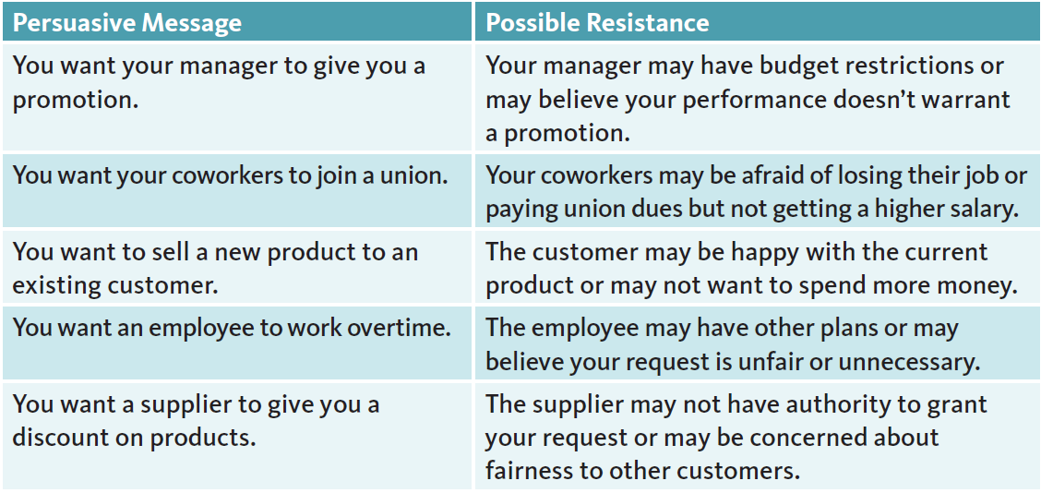

### 7-1c Analyzing Your Audience

Typically, people react to persuasion in one of four ways. We try to avoid it, challenge the message, selectively process information, or assert our own views. When faced with a persuasive message, we might fear change or loss of freedom. We also might sense that we’re being deceived. These concerns explain why people might be skeptical of or hostile to our attempts to persuade.

Not everyone will be resistant. For example, if you announce a change in an organization, people may be indifferent or even supportive. Too often, these groups are ignored as we put all our time and energy trying to persuade the active resisters. **But indifferent people can be inspired to move, and supportive people can be inspired to persuade others.**

**Audience Analysis**

1. Who is the primary audience?
2. What is your relationship with the audience?
3. How will the audience likely react?
4. What does the audience already know?
5. What is unique about the audience?

### 7-1d Tailoring to Your Audience

* **Targeted vs. Generic Messages**
  + Targeted messages are more effective than generic ones.
  + They are adapted based on audience similarities, such as cultural identification.
* **Effectiveness of Cultural Messaging**
  + Deeper cultural messaging is more persuasive than surface-level messaging.
  + Referencing values, traditions, religious beliefs, and norms is more impactful than mentioning music, clothing, or food.
* **Tailoring Messages to Individuals**
  + Advertisers use online data (e.g., past purchases, browsing history) to target consumers.
  + Managers who know their audience personally can craft more effective persuasive messages.
  + Messages perceived as personally relevant increase the likelihood of persuasion.
* **Power of Interpersonal Communication**
  + More effective than both targeted and tailored messaging.
  + Listening more than speaking helps in changing deeply held beliefs.
  + Being open and curious enhances persuasion.

## 7-2 Applying Persuasive Strategies

### 7-2a Start with “Why”

In his book and popular TED Talk, Simon Sinek encourages leaders to start with “why.” Too often, Sinek says, we focus on what or how—what our idea is or how our product works. Instead, as we discussed earlier, the audience comes first. This requires empathy, our ability to see the situation from the other’s perspective.

Tailoring your message to why your audience should care increases the likelihood that they will be persuaded. Let’s say you manage a team of eight employees and, because of cutbacks, need to persuade them to take on additional responsibilities. They each have different motivations for complying.

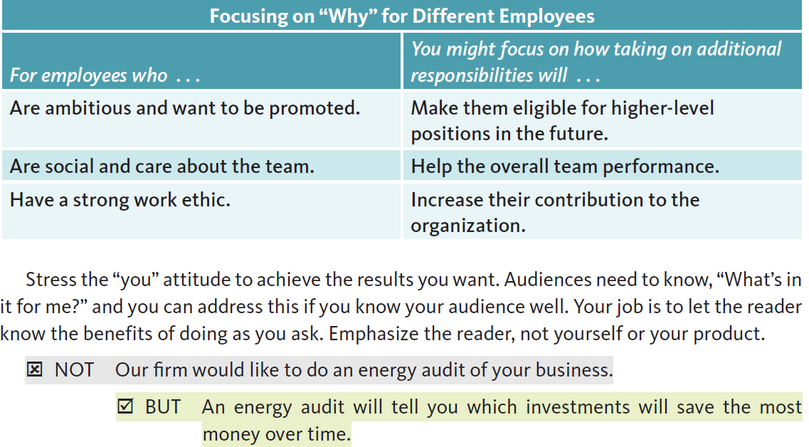

### 7-2b Demonstrate Credibility

In his work *Rhetoric*, Aristotle identified three methods by which people can be persuaded:

* Ethos, demonstrating credibility
* Pathos, appealing to emotion
* Logos, developing logical arguments.

These methods remain as relevant today as they were when Aristotle wrote about them more than two thousand years ago. As part of your process of analyzing your audience, consider which of these methods—or what combination—will work best to persuade each person or group. First, we explore credibility.

You might hear clues about your audience’s resistance to your credibility. You might hear questions about your experience, such as “What’s your background?” or “How long have you been working with Wells Fargo?” Or you might face an audience who is skeptical about your character or ethics. In these situations, your audience may question your motives: “Why are you recommending this proposal to us now?” or “What is our financial agreement with you?”

To address these concerns, demonstrate your credibility. Consider discussing your background up front, sending your bio ahead of time, bringing a more experienced person with you to a meeting, showing examples of your work, or providing references. The more your audience connects with you as a person, the more they may accept you and your opinions.

Integrity is an important component of your character and credibility. When you demonstrate integrity—following through on your commitments and abiding by high moral values—you’ll be perceived as trustworthy. Integrity also involves transparency. Communication should be complete and convey the whole truth.

Consider acknowledging opposing viewpoints. Most business audiences are smart enough to know potential downsides of your idea. If you ignore obvious obstacles, you miss an opportunity to address them—and your omission could damage your credibility. By presenting an entire, integral argument, you let the audience decide how to respond.

### 7-2e Apply Principles of Influence

Seven principles of influence from marketing psychology also should be part of your toolkit. Psychologist Robert Cialdini identified the following from his business research.

**Liking: People Like Those Who Like Them:** *“Uncover real similarities and offer genuine praise.”*

Note that Cialdini emphasizes honesty and authenticity—“real” and “genuine”—rather than forced connection or false praise. Climate scientist Katharine Hayhoe talks about openly identifying as an evangelical Christian. She finds that sharing about herself builds a connection around common values, and then people are more willing to talk about environmental issues.

**Reciprocity: People Repay in Kind:** *“Give what you want to receive.”*

In fundraising letters, organizations may include a small gift, banking on the principle of reciprocity—that you will be more likely to donate in return. At work, if you help a coworker with a project, you are far more likely to get help when you need it.

**Social Proof: People Follow the Lead of Similar Others:** *“Use peer power when it’s available.”*

Peer *pressure* could be unethical, but showing people that others have already signed onto an idea will persuade them to agree. Employees who advocate for change within their company have an easier time enlisting support as more join on. As another example, the World Wide Fund for Nature (WWF) in the United Kingdom has a rolling count of people who sign up on its website (Figure 7).

**Commitment and Consistency: People Align with Their Clear Commitments**

*“Make their commitments active, public, and voluntary.”*

If you sign a petition, you are more likely to donate to an organization. That’s why the WWF wants you to sign up to receive email. Minutes taken during a meeting serve a similar purpose: once people commit to a task, they are more likely to follow through.

**Authority: People Defer to Experts:** *“Expose your expertise; don’t assume it’s self-evident.”*

Authority relates most closely to credibility. With both humility and confidence, tell people that you know what you’re talking about. For example, if you’re trying to persuade people to adopt your solution, you might offer evidence of how you have solved similar problems in the past.

Companies hire celebrities to endorse their products because the public perceives them to be credible. However, to comply with U.S. laws, people must disclose when they receive compensation—to acknowledge that they are paid to act as experts.

**Scarcity: People Want More of What They Can Have Less Of:** *“Highlight unique benefits and exclusive information.”*

When you shop online and see “Only 2 left at this price!” or “Order before May 14,” the company is using the principle of scarcity. We place a higher value on what we can’t have, for example, first-class seats on airplanes and access to limited-occupancy nightclubs.

**Unity: People Are Influenced by Shared Identities**

*“Identify in terms of a group . . . to form a sense of self-esteem and pride.”*

Cialdini added this seventh principle after noticing shared identities as an undercurrent of the others, helping us make quick decisions about, for example, whether we like the person or view someone as an authority. We are more likely to be persuaded by people with whom we identify, for example, if we’re part of the same family, religious group, college, or hometown. When people hear “we,” are asked for advice, or are treated as an insider, they are more likely to comply with our requests.

Be careful with these seven principles and all persuasive strategies. They are powerful tools but should never be abused to take advantage of people. Damaged relationships may never heal. Next, we see how persuasion is used in written messages.